AWS KMS (Key Management Service)
Prerequisites
- AWS Account
- IAM User with Administrator Access
- Region: US East (N. Virginia) us-east-1

What is AWS KMS?
AWS Key Management Service (KMS) is a managed service that helps create, store, manage and control encryption keys used to encrypt your data.
Instead of managing encryption keys yourself, AWS securely manages them.

Real-world Example
Imagine a bank.
- Customer data is stored inside lockers.
- The lockers represent your AWS resources (S3, EBS, RDS).
- The locker keys represent KMS Keys.
Without keys, nobody can open the lockers.

AWS KMS Architecture
+-----------------------+
| IAM Users |
+----------+------------+
|
|
IAM Policies
|
v
+------------------+
| AWS KMS |
| Customer Managed |
| Keys |
+---------+--------+
|
---------------------------------------------
| | | |
| | | |
S3 EBS RDS Secrets Manager
| | | |
---------------------------------------------
|
Encrypted Data

Types of KMS Keys
Type | Managed By | Cost | Rotation
AWS Managed Key | AWS | Free | Automatic
Customer Managed Key | User | Charges Apply | Automatic or Manual
Imported Key | User | Charges Apply | Manual

1: Create a Customer Managed Key
Step 1
Login to AWS Console
Go to
AWS Console
→ Search
→ KMS
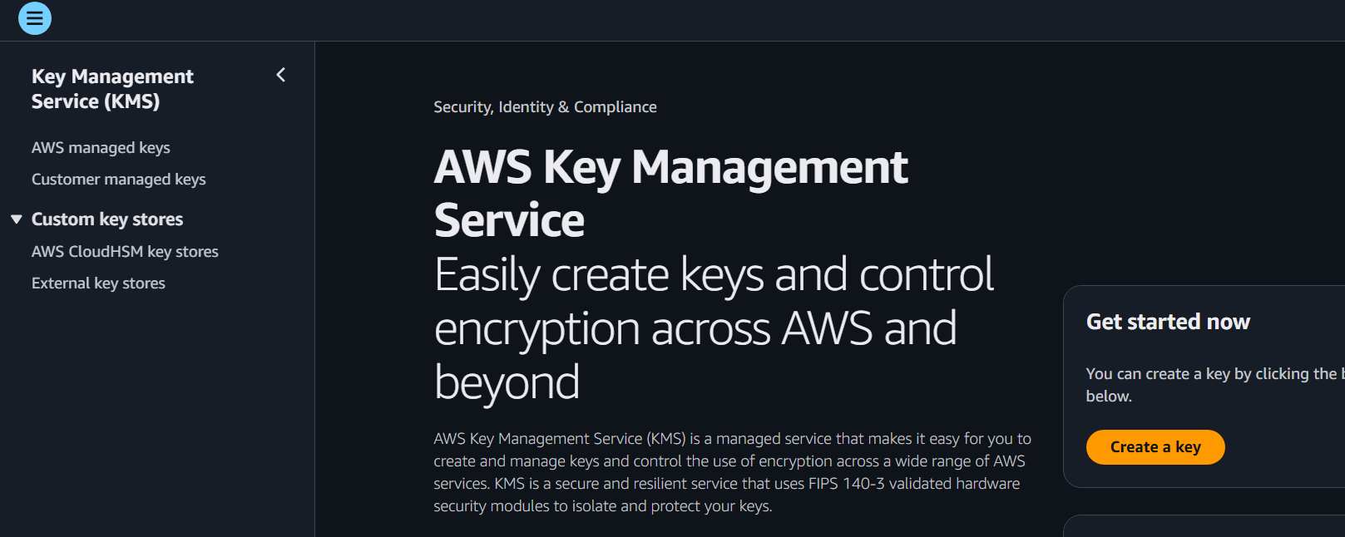

Step 2
Click
Customer managed keys
Click
Create Key

Step 3
Select
Symmetric
Because symmetric keys are used for encryption/decryption.
Click
Next
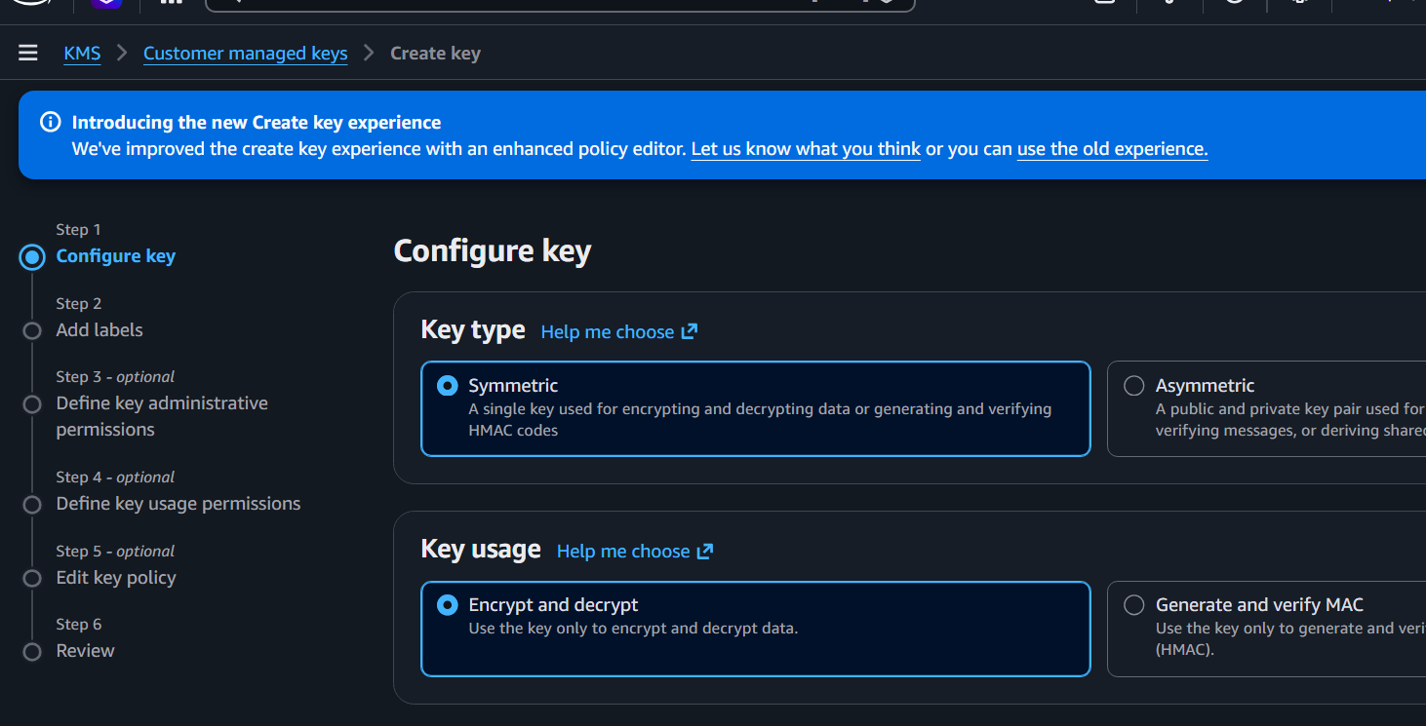

Step 4
Key Alias
Example
DevOps-KMS-Key
Description
KMS key for DevOps Lab
Click
Next
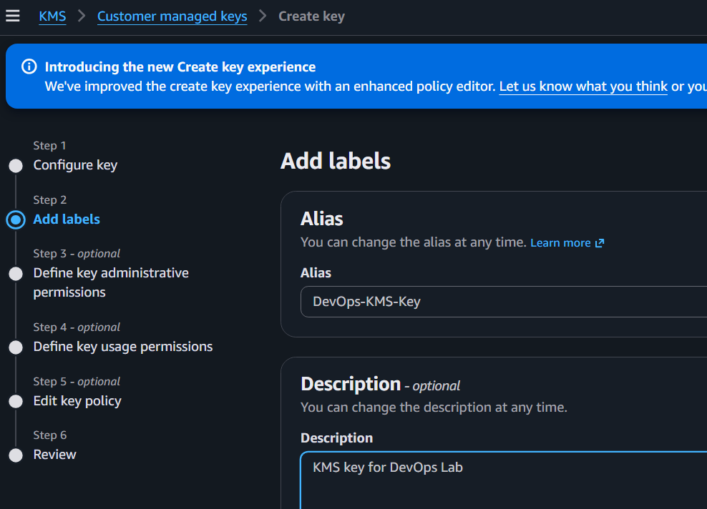

If IAM User not available create one IAM user with S3 full access
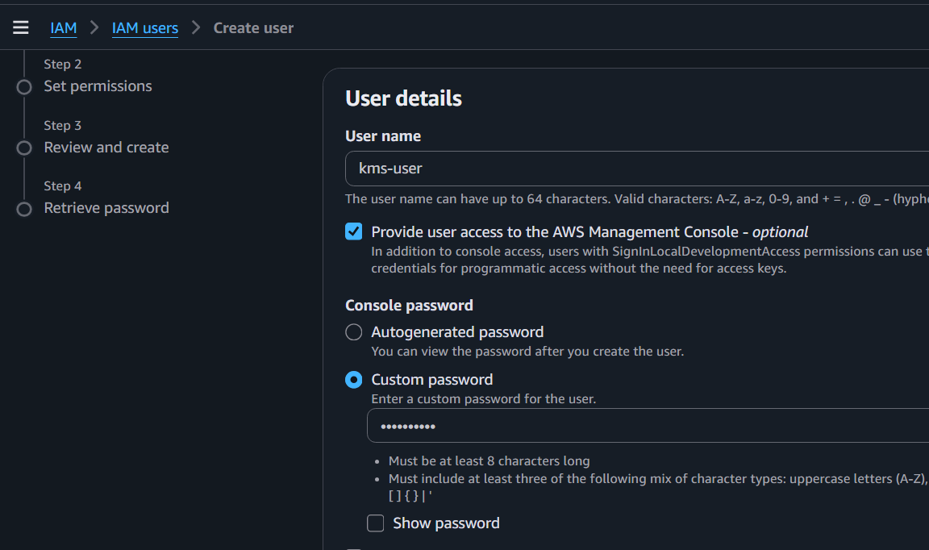
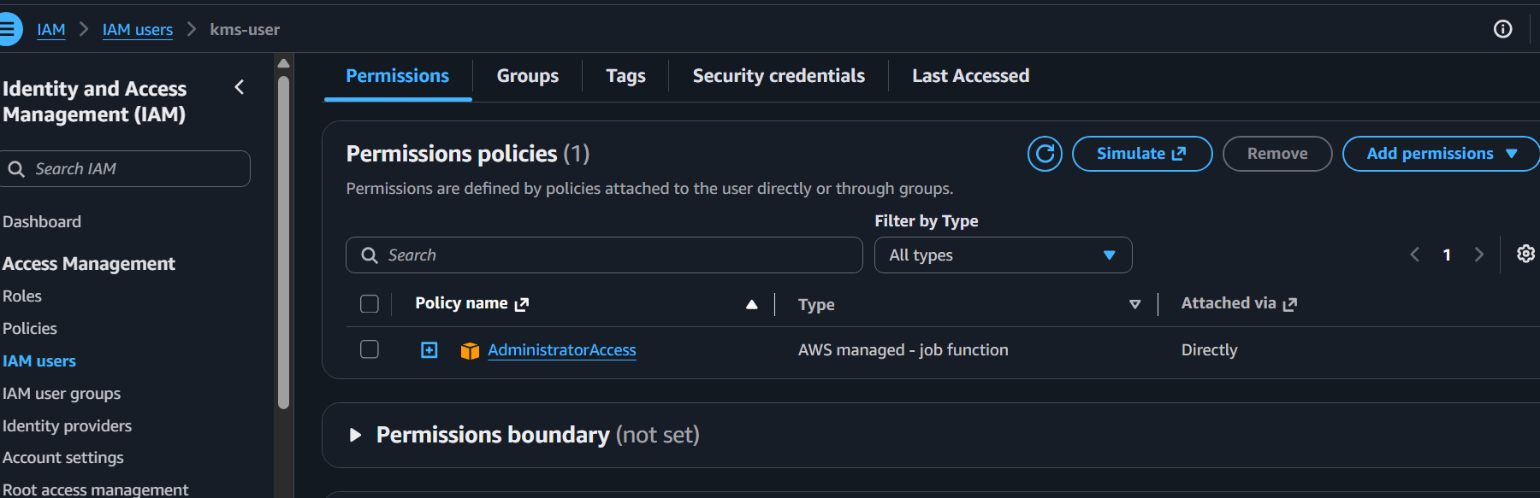
Step 5
Key Administrators
Choose your IAM user.
Click
Next

Step 6
Key Users
Choose
Your IAM User
Click
Next
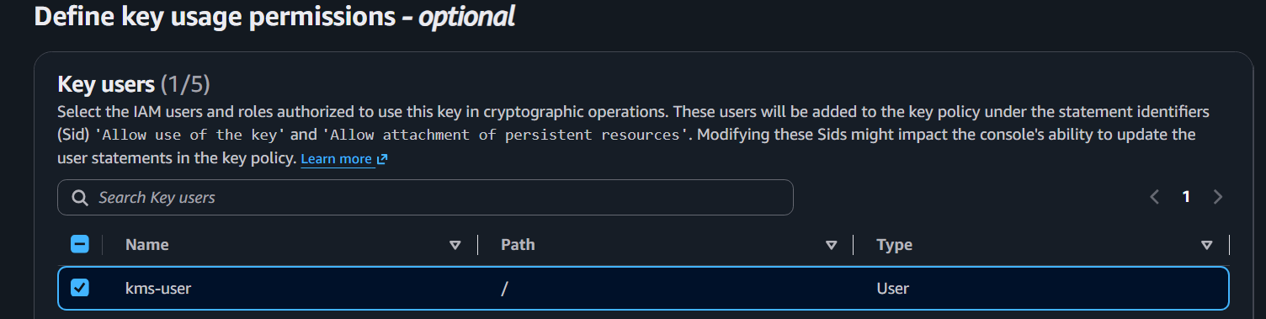

Step 7
Review
Click
Finish
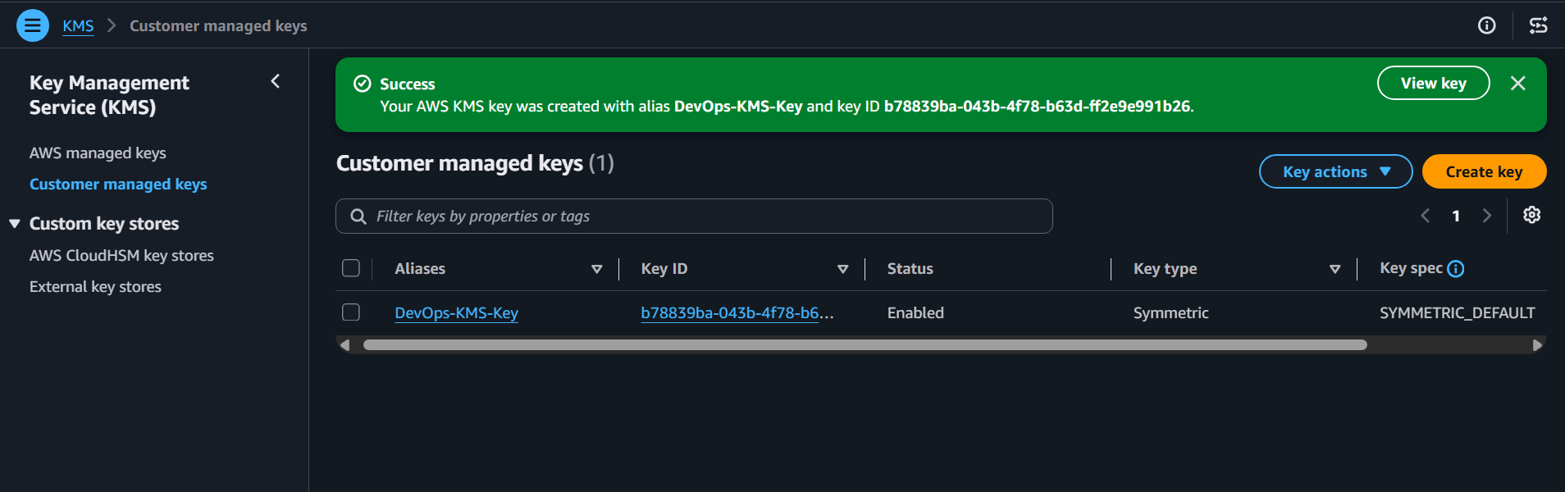

You now have your own Customer Managed Key.

Hands-on Lab 2: Encrypt Text Using AWS KMS
Open
AWS Console
→ KMS
Select
DevOps-KMS-Key
Click
Cryptographic configuration
Choose
Encrypt
Enter
Hello DevOps
Click
Encrypt
AWS generates encrypted ciphertext.
Example
AQICAHgfdhsgd76jdh.....
Copy it.

Hands-on Lab 3: Decrypt Text
Paste encrypted ciphertext.
Click
Decrypt
Output
Hello DevOps

Hands-on Lab 4: Encrypt an S3 Bucket
Step 1
Create S3 Bucket
Example
devops-kms-demo-123
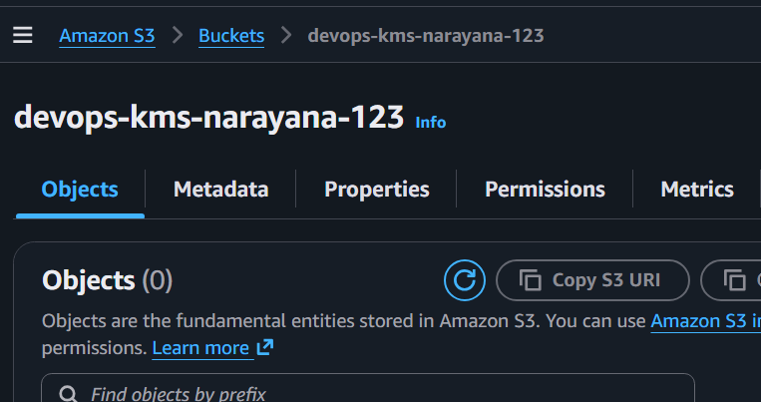

Step 2
Open bucket
Go to
Properties
Scroll down
Default Encryption
Choose
AWS KMS Keys
Select
DevOps-KMS-Key
Save.
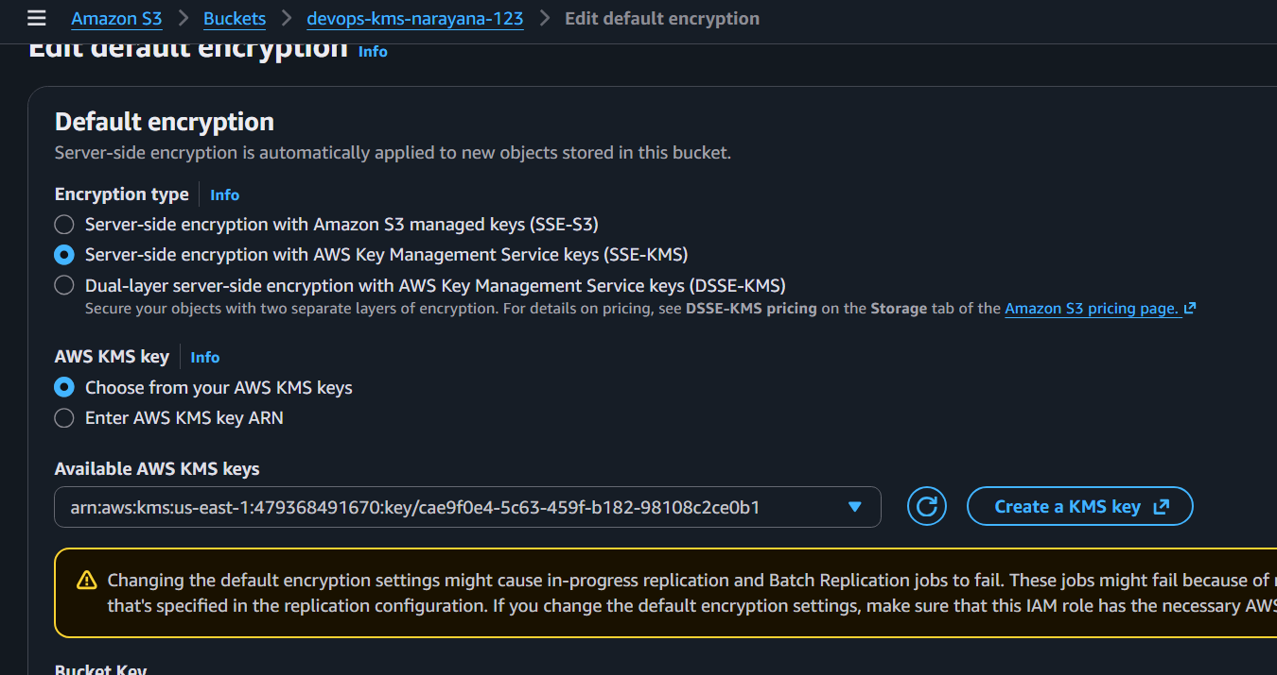

Step 3
Upload a file
Example
test.txt
Now every object uploaded is encrypted using your KMS key.
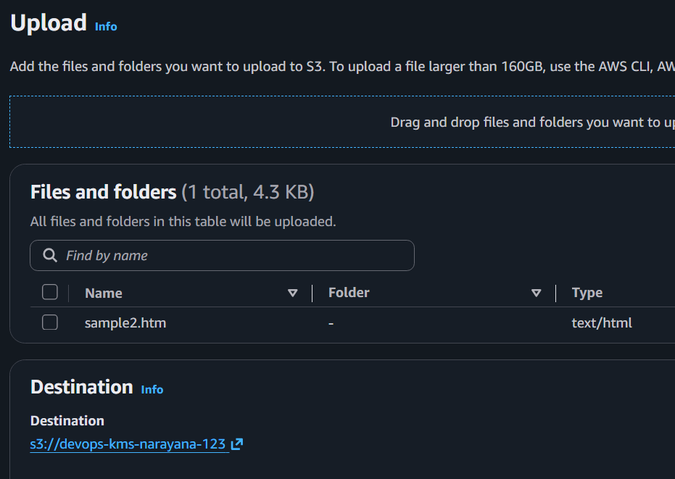

Verify Encryption
Open uploaded file
Go to
Properties
You should see
Server Side Encryption
AWS KMS
Key
DevOps-KMS-Key
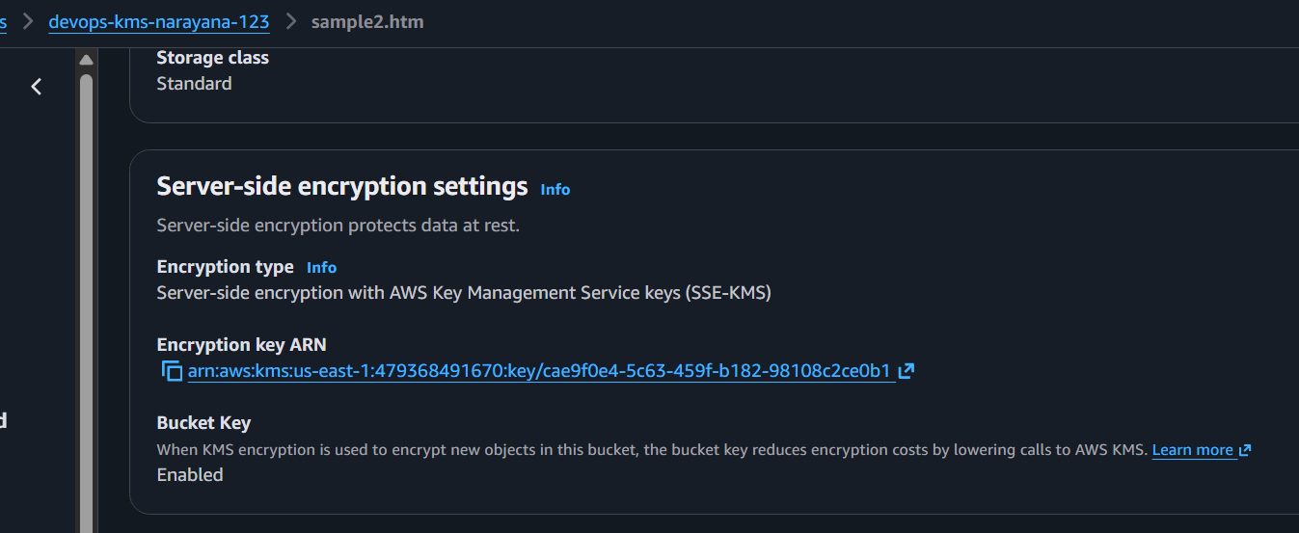

Hands-on Lab 5: Encrypt Existing Object
Select object
Choose
Copy
Copy to same bucket
Select
Replace Encryption
Choose
AWS KMS
Save.
The object is now encrypted using KMS.
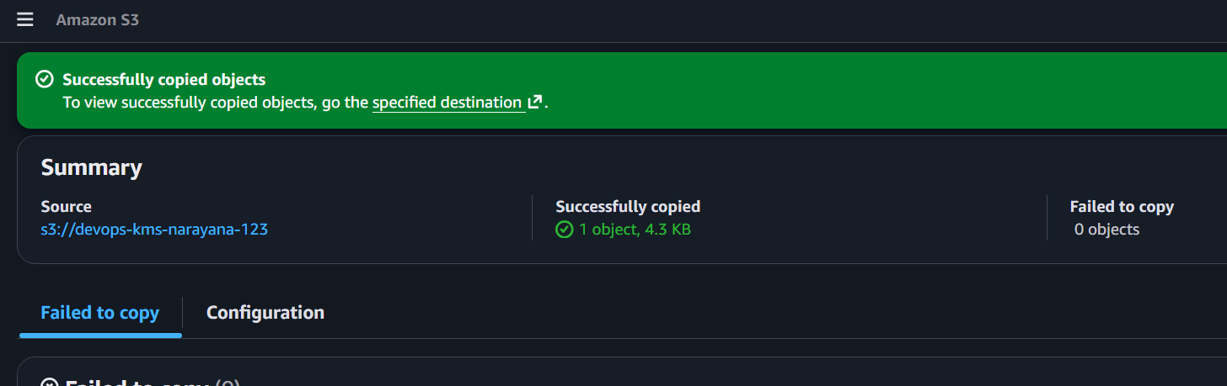
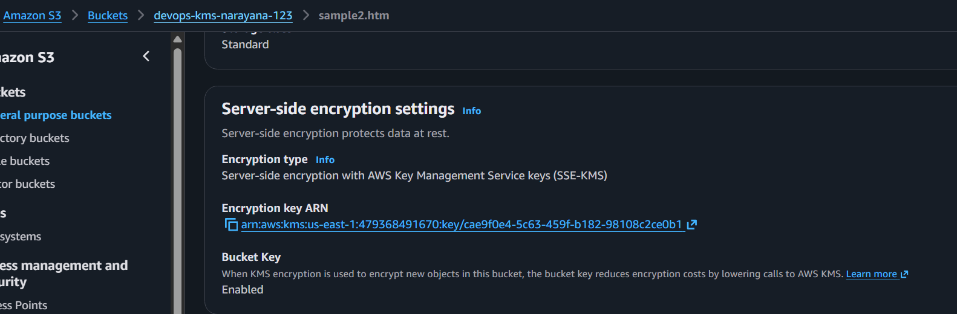

Hands-on Lab 6: Enable Automatic Key Rotation
Open
Customer Managed Key
Select
Key Rotation
Click
Enable Automatic Rotation
Save.
AWS rotates the backing cryptographic material automatically (supported for symmetric customer-managed keys).
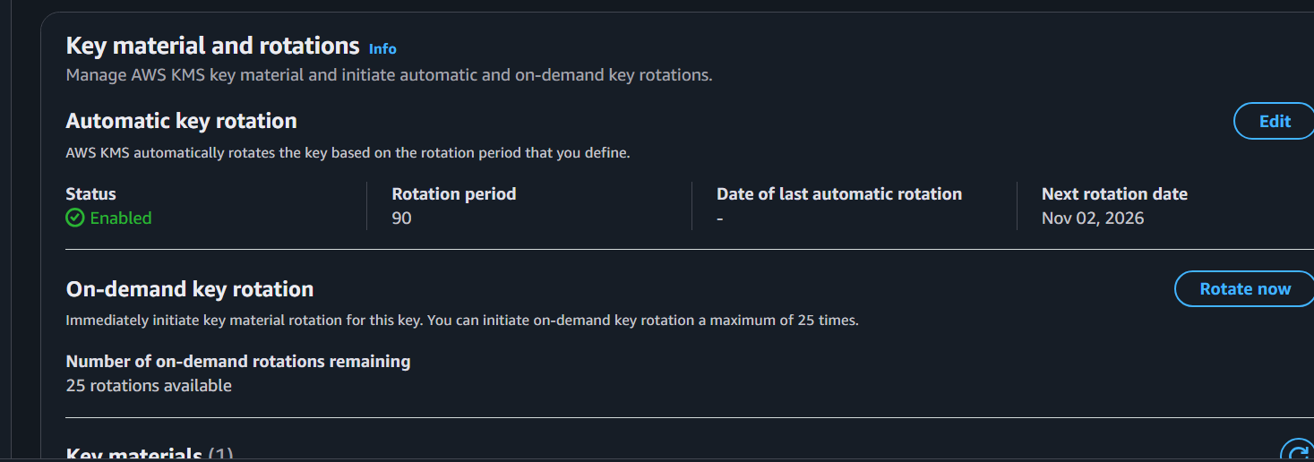

Hands-on Lab 7: View Key Policy
Open
Key Policy
Example
{
"Version":"2012-10-17",
"Statement":[
{
"Sid":"Enable IAM User Permissions",
"Effect":"Allow",
"Principal":{
"AWS":"arn:aws:iam::123456789012:root"
},
"Action":"kms:*",
"Resource":"*"
}
]
}
Key Policy controls
- Who can use the key
- Who can encrypt
- Who can decrypt
- Who can delete
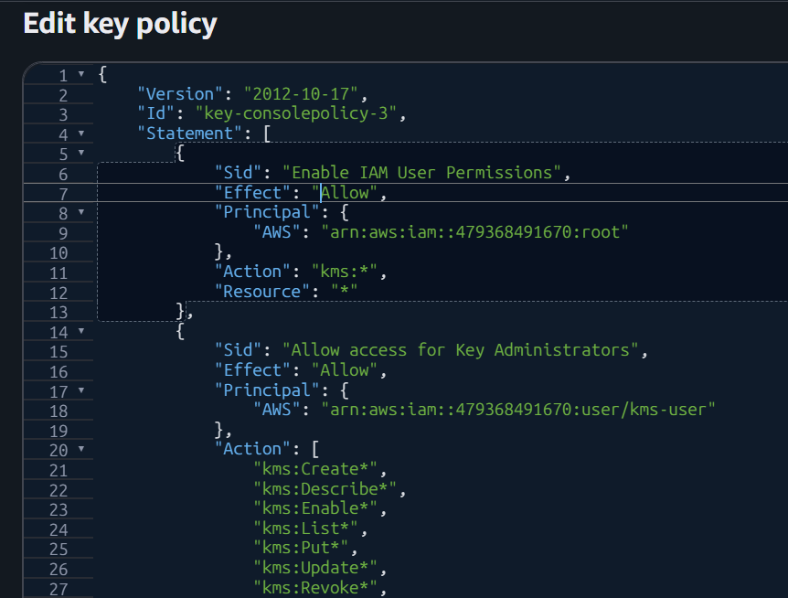

Hands-on Lab 8: CloudTrail Logging
Open
CloudTrail
Go to
Event History
Filter
Event Source

kms.amazonaws.com
You will see
- Encrypt
- Decrypt
- CreateKey
- DisableKey
- ScheduleKeyDeletion
This proves all KMS activity is logged.
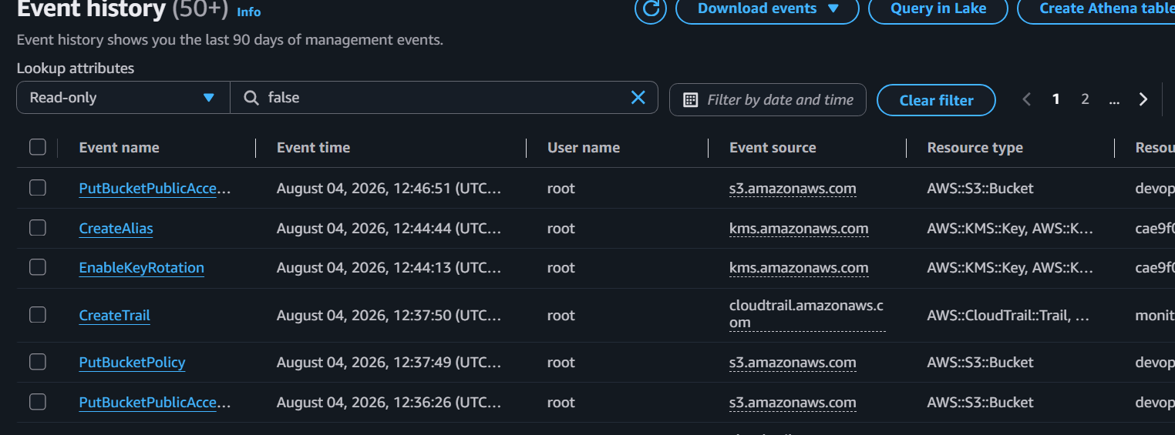

AWS LAMBDA
1. What is AWS Lambda?
AWS Lambda is a serverless compute service that lets you run code without creating or managing
servers. You upload your code, and AWS runs it automatically when an event occurs.
2. Components of Lambda
Component Purpose
Function Your application code
Trigger Starts the Lambda function
Runtime Programming language (Python, Java, Node.js, etc.)
Handler Entry point of your code
IAM Role Permissions to access AWS services
Environment Variables Store configuration values
Layers Reusable libraries and dependencies
CloudWatch Logs and monitoring
3. Why Use Lambda?
Use Lambda when:
✅ Build REST APIs with API Gateway
✅ Process files uploaded to S3
✅ Send notifications (SNS)
✅ Process SQS queue messages
✅ Run scheduled jobs (EventBridge/Cron)
✅ Process DynamoDB Streams
✅ Automate AWS tasks (backups, tagging, cleanup)
4. Why NOT Use Lambda?
Lambda is not a good choice when:
❌ Applications run continuously (24×7)
❌ Long-running jobs (more than 15 minutes)
❌ Large applications requiring full server control
❌ Software that needs a GUI
❌ Applications with persistent local storage requirements
Example:
Running a database like MySQL or hosting a full Tomcat server is not suitable for Lambda. Use
EC2, ECS, EKS, or RDS instead.
AWS Lambda Hands-on
Lab 1: Create Your First Lambda Function
Step 1: Open Lambda
Log in to the AWS Console.
Search for Lambda.
Open the Lambda service. 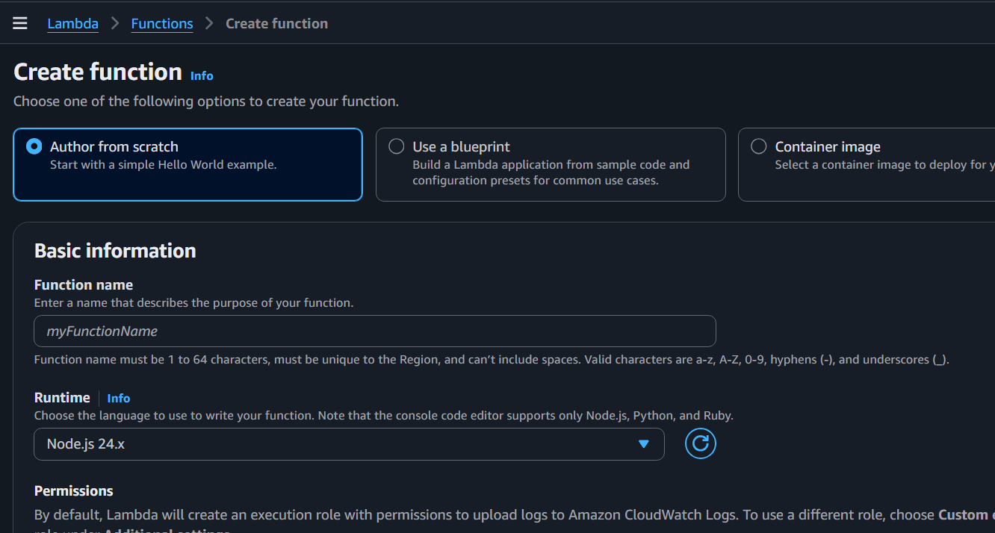
Step 2: Create Function
Click Create function.
Select:
Author from scratch
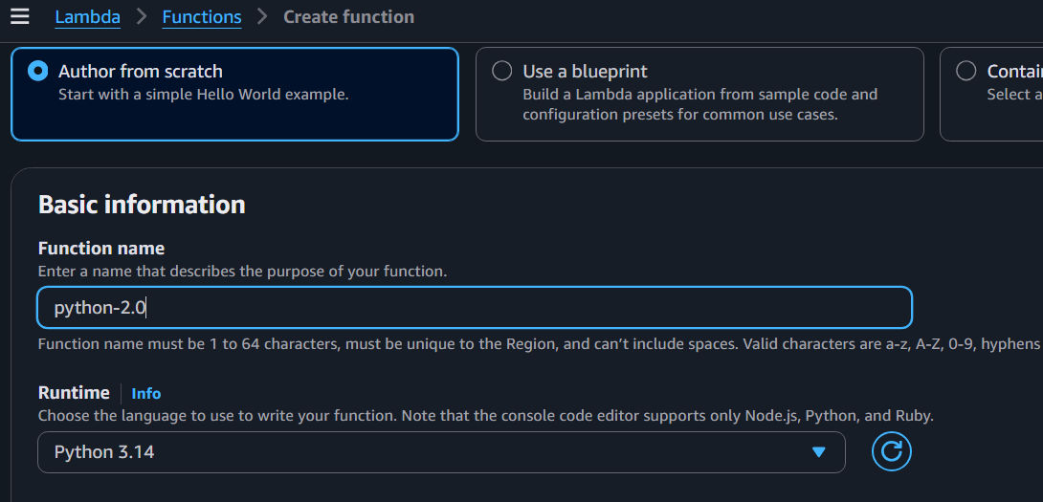
Step 3: Write Code
Go to the Code tab.
def lambda_handler(event, context):
return {
"statusCode": 200,
"body": "Hello AWS Lambda"
}
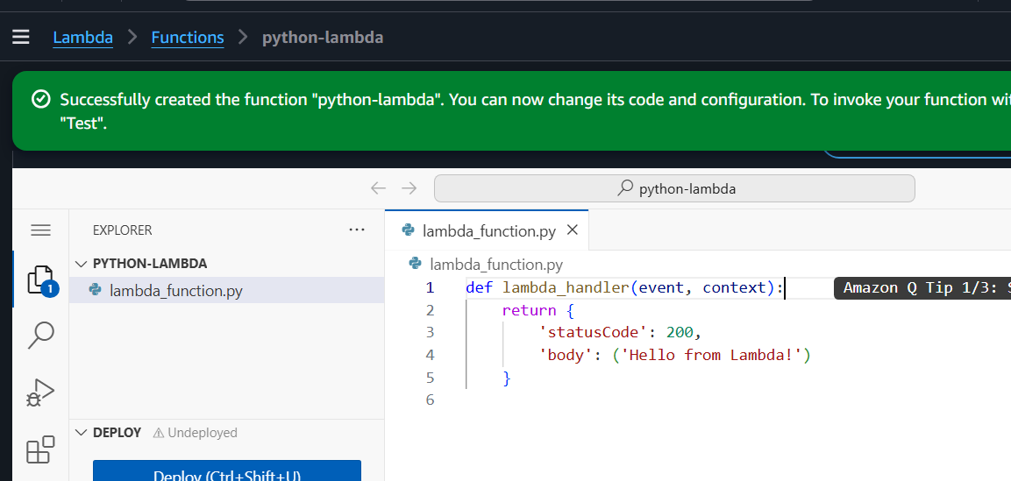
Step 4: Deploy
Click Deploy.
Purpose: Saves the latest code to AWS so it can be executed.
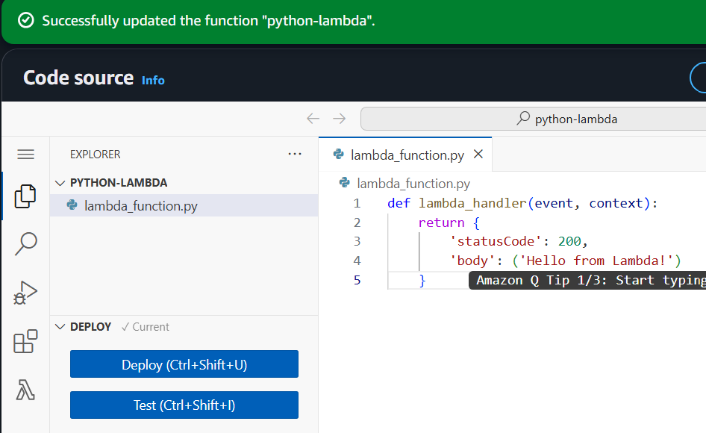
Step 5: Test
Click Test.
Event name: Test-py
Keep the default JSON:
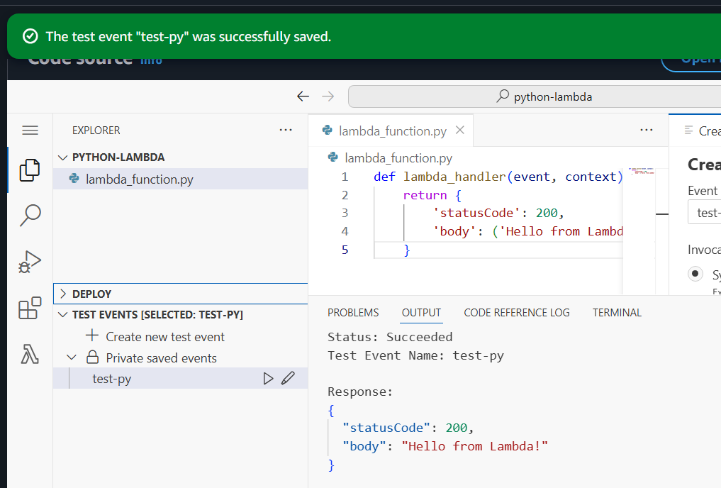
Step 6: View Logs
Go to: Monitor → View CloudWatch Logs
Open the latest log stream.
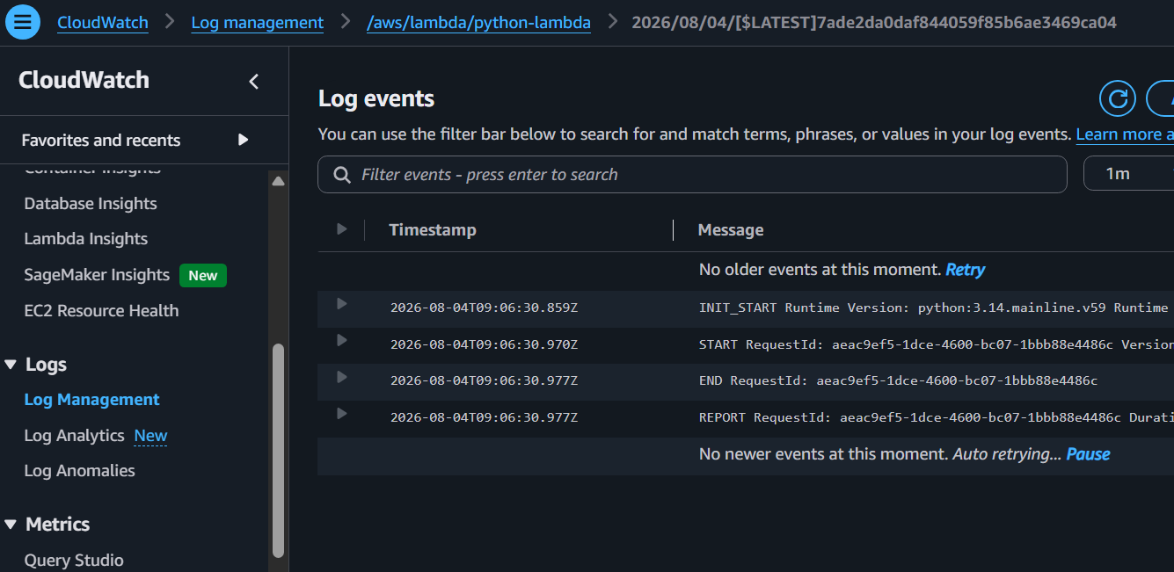
Update Lambda Code
1. Edit the code.
2. Click Deploy.
3. Click Test.
4. Verify the updated output.
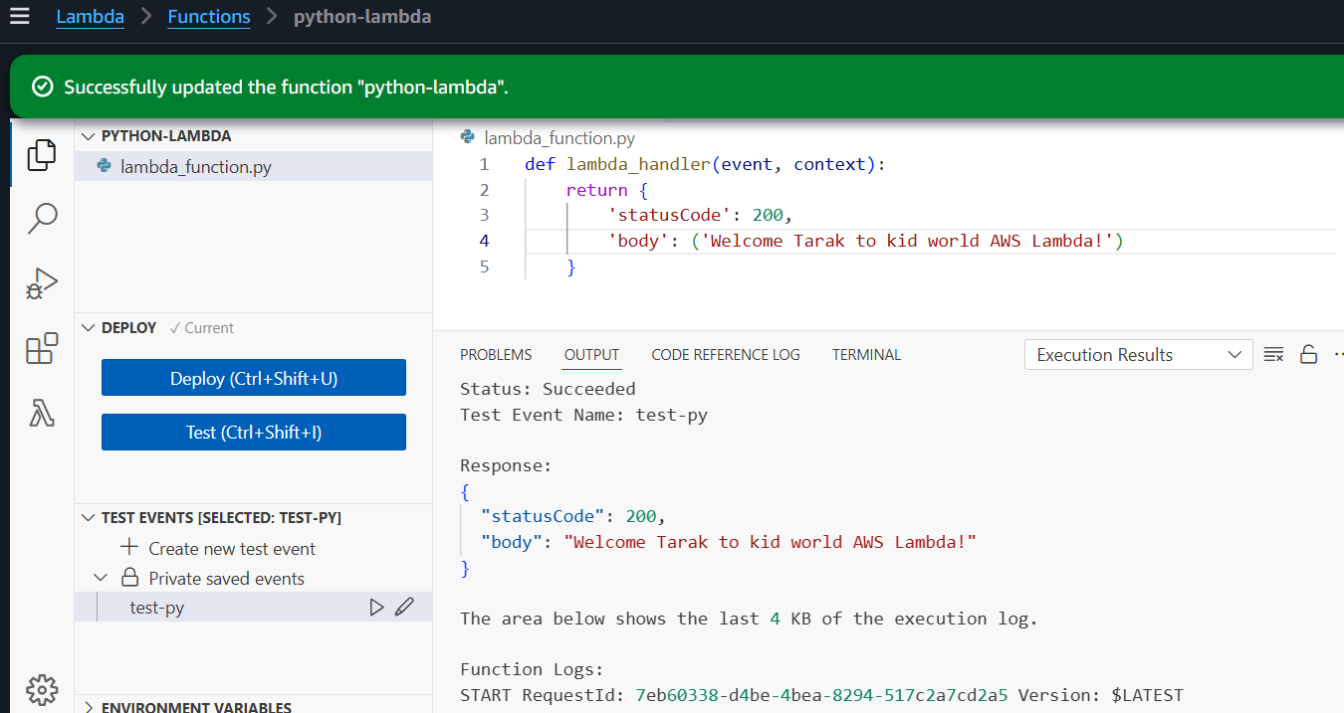
Remember: Every code change requires Deploy before testing.
Add Environment Variables
Go to:
Configuration → Environment Variables → Edit
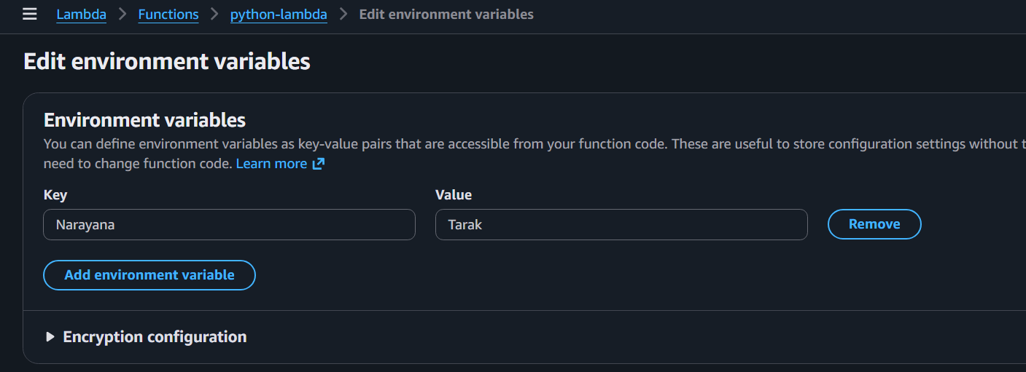
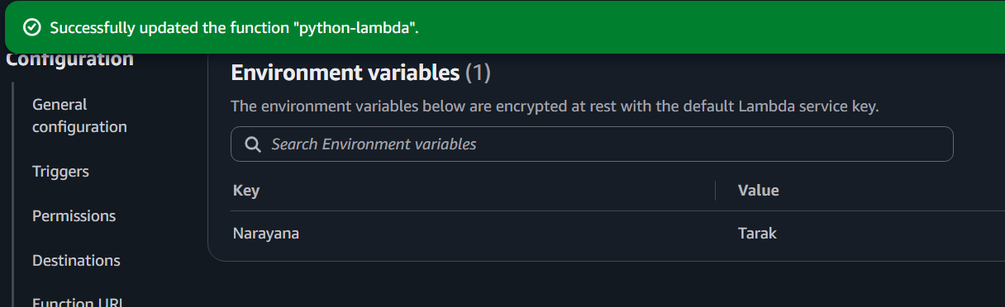

AWS API Gateway
Step 1: Open API Gateway
AWS Console → Search API Gateway
Click API Gateway
Step 2: Create API
Click Create API
Select HTTP API
Click Build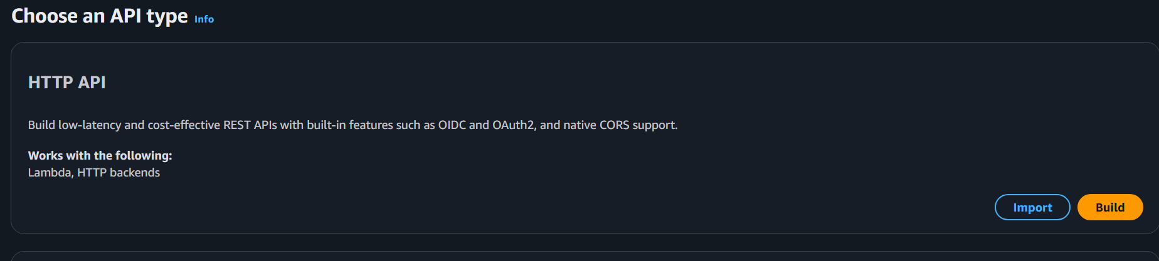
Step 3: Add Integration
Click Add Integration
Integration type: Lambda
Select your Lambda function (e.g., python-demo)
Click Next
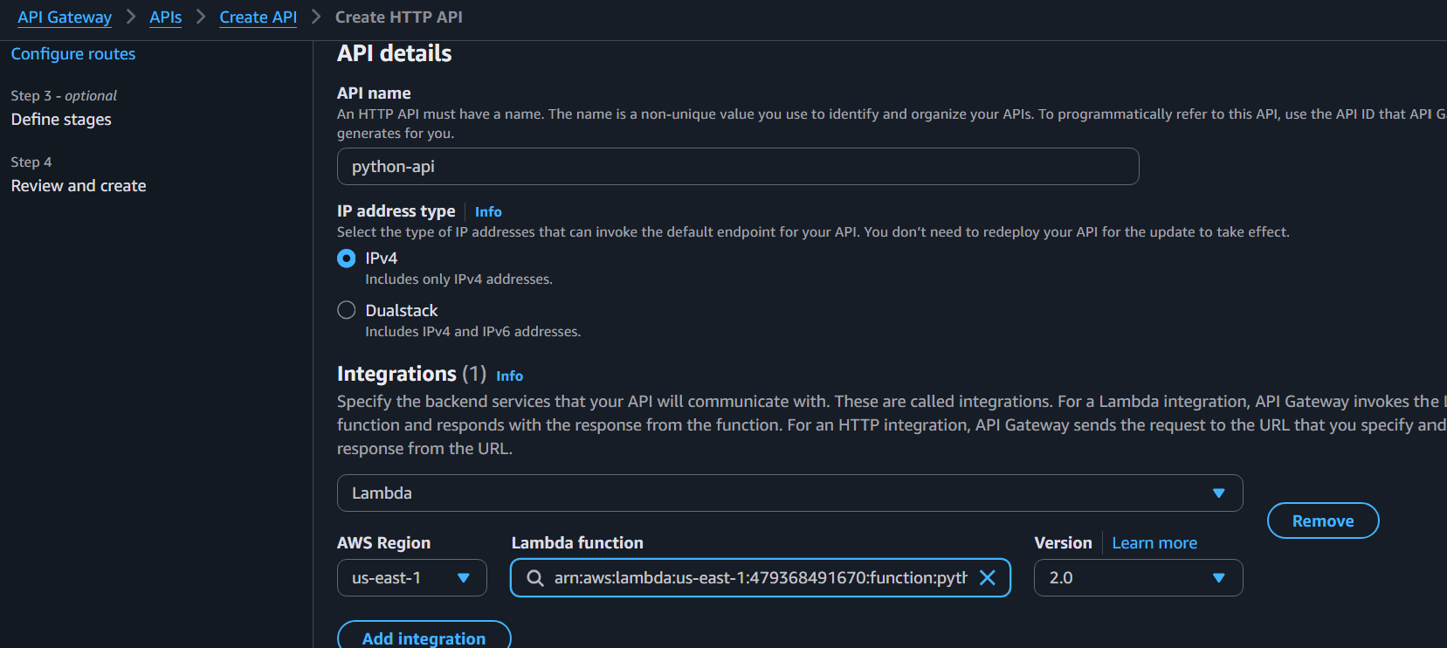
Step 4: Create Route
Method: GET
Path: /hello
Click Next
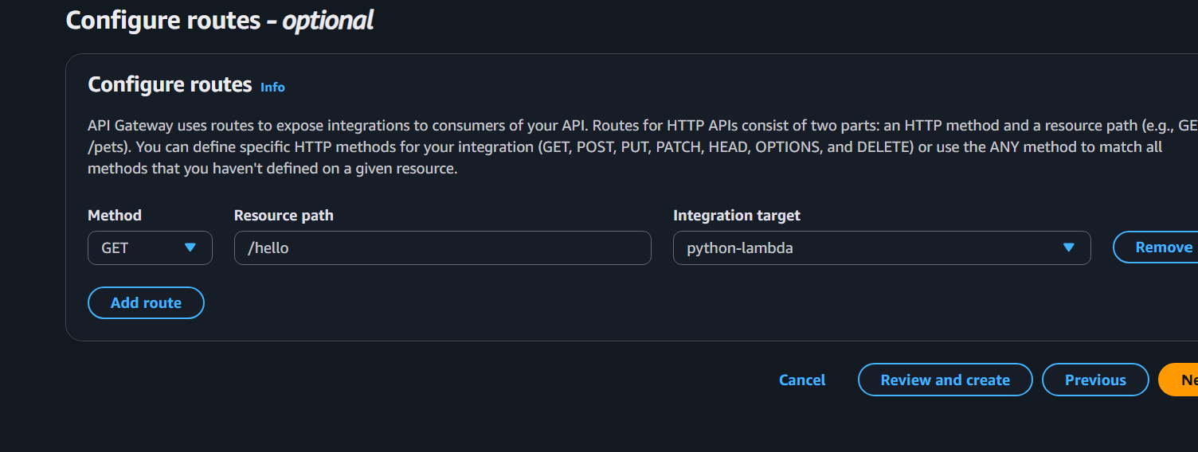
Step 5: Create Stage
Stage name: prod
Click Create
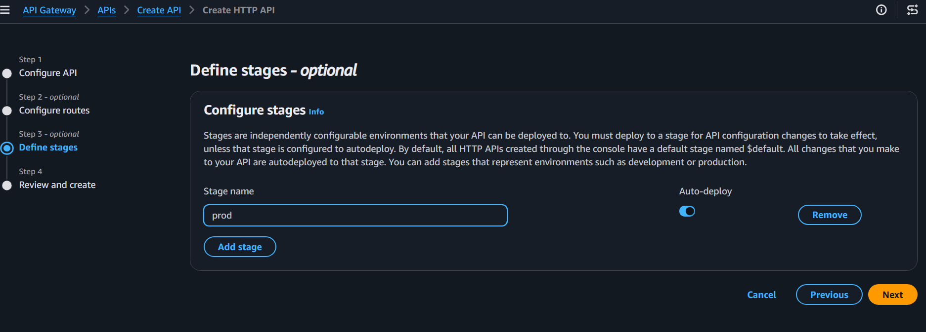
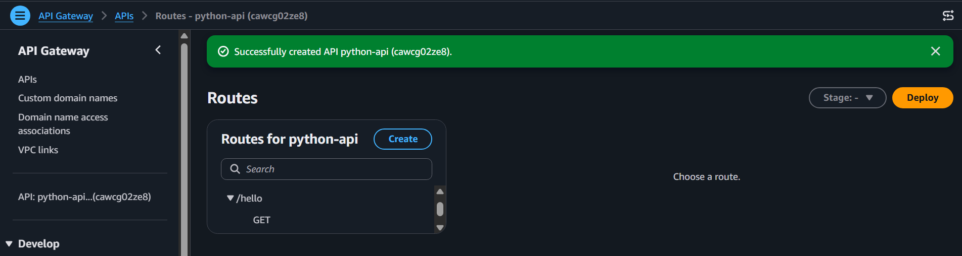
Step 6: Copy Invoke URL
Example:
https://cawcg02ze8.execute-api.us-east-1.amazonaws.com/prod
Append the route:
https://cawcg02ze8.execute-api.us-east-1.amazonaws.com/prod/hello
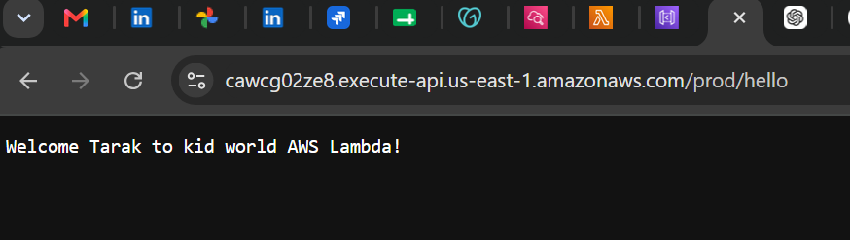
Step 7: Test API
Open the URL in a browser or Postman.
You should see:
{
"statusCode": 200,
"body": "Hello AWS Lambda"
}
Step 8: Verify Logs
Go to:
Lambda → Monitor → View CloudWatch Logs
Open the latest log stream and verify the API request reached Lambda.
